Self-Care tips to Prevent Secondary Traumatization
Nurturing Self Care (prevent in burnout)
- Eat sensibly and regularly everyday
- Get adequate sleep each night
c. Exercise regularly
d. Take regular breaks during the day (to reduce the fatigue that may leave you more vulnerable), take time off when you need to. Note: with the influx of traumatized clients this may difficult but it’s still important.
e. Maintain a heathy balance with work and have outside interests. Also, where you can balance you case load with of mix of more and less traumatized clients, victims, and non-victims.
- Seek social support from colleagues and family.
- Use a buddy system particularly when you are less experienced.
- Use peer support and opportunities to debrief.
- Get further training with treating trauma where you can.
Awareness

- Increase your self-observation when working with Trauma Victims. Recognize and chart your signs of stress, vicarious trauma, and burnout.

- Be realistic about what you can accomplish, avoiding wishful thinking.

- Don’t take on responsibility for your client’s well-being but supply them with tools to use to look after themselves. Remember just listening and holding space for our traumatized clients is still a gift to them.
- Reference regarding Trauma
- The Body Keeps the Score: Brain, Mind, Body in the Healing of Trauma by Bessel van der Kolk MD. (New York Times Best Seller)
- Getting Past Your Past: Take Control of Your Life with Self-Help Techniques from EMDR Therapy by Francine Shapiro Ph.D.
- www.emdrhap.org
- info@emdrhap.org 203-288-4450
- www.emdria.org
- https://www.emdrhap.org/content/about/what-is-emdr/
- https://emdrfoundation.org/emdr-info/research-lists/
- www.traumacenter.org

- Free work sheets at: emdrconsulting.com
- The Vicarious Trauma Tool Kit which includes a Compendium of Recourses.
EMDR:
My 25 yrs. experience with Children, Adolescents and Adults using EMDR
Sexual Assault, War Veterans, Natural Disaster Survivors, Traumatic Workplace Accidents
My Training- 3 days for level 1 and 3 days for level 2 trainings.
8 yrs. in an EMDR Consultation Group with a National Trainer facilitating.
Story of why I learned it.

EMDR- Eye Movement De-sensitization and Reprocessing Describe (Share Screen SUD’s Scale)
Screen share-Organizations that recognized EMDR as well researched and effective treatment
E.M.D.R. therapy targets the way in which memories are stored in the brain.
It is one way of harnessing our brains Neuroplasticity
Method –is the use of Bilateral Stimulation of the Brain acting as a catalyst to activate our brain’s ability to resume its natural healing process of where we learn, modify, and adapt.

EMDR is designed to resolve unprocessed traumatic memories in the brain. And more quickly than other psychotherapies.
Note: EMDR works more quickly with children than adults. Share my surprise with children.
You can use Bilateral Eye movements, bilateral sounds, bilateral tapping, Bilateral Sensations (tappers) to create the activation process
DR. Bessel Van der Kolk (MD.) who is the founder and Medical Director the Trauma Center in Brookline Massachusetts Wondered why in the last 100 yrs. we didn’t figure this out until now. He also said that” After you have been traumatized you live in a different universe.” Herman, van der Kolk & Perry, 1989 found high % of Childhood trauma in borderline personality disorder

Bessel Von de Kolk agrees with Virginia Satir that you can’t heal yourself without going inside (below the surface of the iceberg)

BLS is the catalyst for activating the brains ability to heal distressing memories. It is based on the concept of
Adaptive Information Processing Model (AIP) – processing data from memories – images, negative cognitions, emotions, and body sensations. Think of digital information stored on your phone and computer.
Experiential Data incompletely processed by the brain’s natural & inherent information processing system. Due to the overwhelming affective state that occurs during Trauma, there is Incomplete processing means that a disturbing event has been stored in memory as it was originally experienced with the emotions, physical sensations, and beliefs fundamentally unchanged. Think of this as an M&M. Regardless of how much time has elapsed or whether the person remembers it, the memory remains unaltered and provides the basis of current responses and behaviors.

This model is consistent with modern neurobiological findings

THE VALUE It allows vivid images to fade or get more distant. Emotions and body sensations calm. Left Brain Linkages occur, providing insight and adaptive learning.
EMDR does not erase memories but transforms them from maladaptive to adaptive memories that are now resources (Virginia Satir). A shift from suffering in the present to thriving.

Theory – Trauma Memories are stored in the right brain (Functional MRI studies).
The trauma memory is isolated in the right brain (M&M metaphor). Frozen in time
There it can’t access other useful information from other parts of our brain- like the logical, verbal left brain. Which is why left brain talking therapy isn’t effective. (ex. Older Vietnam Vet who couldn’t get the left-brain information he knew (I survived) to be associated with his Trauma memory from the war and the negative cognition “I’m going to die”
Creating a Maladaptive Memory – explain & relate it to suffering.

The Bilateral Stimulation is a catalyst for activating our Adaptive Learning System which allows for reprocessing distress memories. (Changing the M&M into a semipermeable membrane that allows new information to get thru.)
EMDR goal is to change this to an adaptive memory that we can refer to and use as a resource (Virginia Satir). Keeping what is necessary from a past experience and letting go of the information (data) that is no longer needed.

EMDR activates different parts of the brain
The prefrontal cortex- so we can know the trauma is then and NOT NOW.
Insula—so my body can feel safe now.
Temporal Parietal Junction – which helps a person simultaneously hold both a subjective(then) and objective(now) working memory which processing of the memory of the sensations and thoughts are being processed.
The Midline structure of the brain needs to be reactivated to get to calm the Amygdala (fear structure)

One of the important things is that EMDR therapy does not require talking about the distressing issue. Explain why this important. (Helps with avoidance and is less activating)
Before Processing in the Preparations phase-
I install a SAFE PLACE -explain the difference between images and installation.
This might be something Trauma workers could help children create to CHANGING THE CHANNEL.
We use SLOW BLS to install the Safe Place because faster BLS is activating.
Slow BLS enhances the calm soothing positive image/experience, allowing the client to “settle into” this positive experience”. They are then able to get to this calm, relaxed more quickly.
Note: some individuals are not able to locate a memory of a place they feel safe as a result of their past experiences – so I encourage them to take their time to create a place with characteristics that does feel safe. (ex. An island, place in the clouds or a planet where others cannot get to them.)

I might also help them create a CONTAINER or Vault. This is something they create which is strong enough to hold whatever images, feelings, thoughts, and sensations they put into it. It has a 2 way-valve system so you can put memories in and take them out again when you want to work on them (between sessions).

Mention the Recent Event Protocol

Useful tool for helping those with Trauma

Eye Movement Desensitization and Reprocessing (EMDR) Therapy is an extensively researched and effective psychotherapy method proven to help people recover from trauma and other distressing life experiences, including PTSD, anxiety, depression, and panic disorders.
The following organizations recognize EMDR therapy as an effective treatment.
The American Psychiatric Association,
American Psychological Association
International Society for Trauma Stress Studies
National Alliance for Mental Illness
Health Services Administration
The UK National Institute for Health and Care Excellence
US Dept of Veterans Affairs/Dept of Defense
World Health Organization
Australian National Health and Medical Research Council
Haute Autorité de la Santé (France)
Association of the Scientific Medical Societies in Germany
Dutch National Steering Committee Guidelines Mental Health Care
Are among the many other national and international organizations that recognize EMDR therapy as an effective treatment.
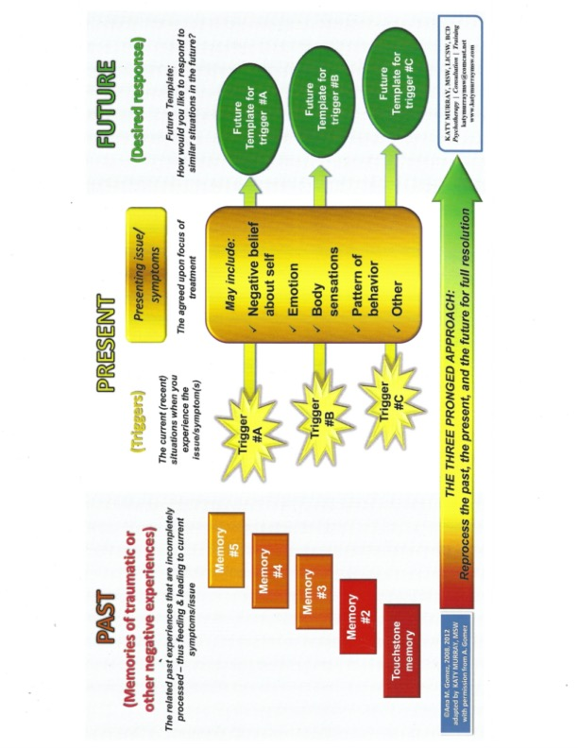
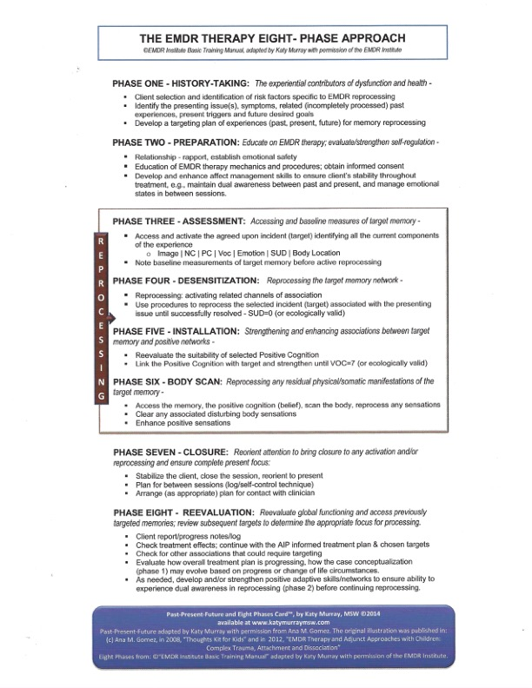
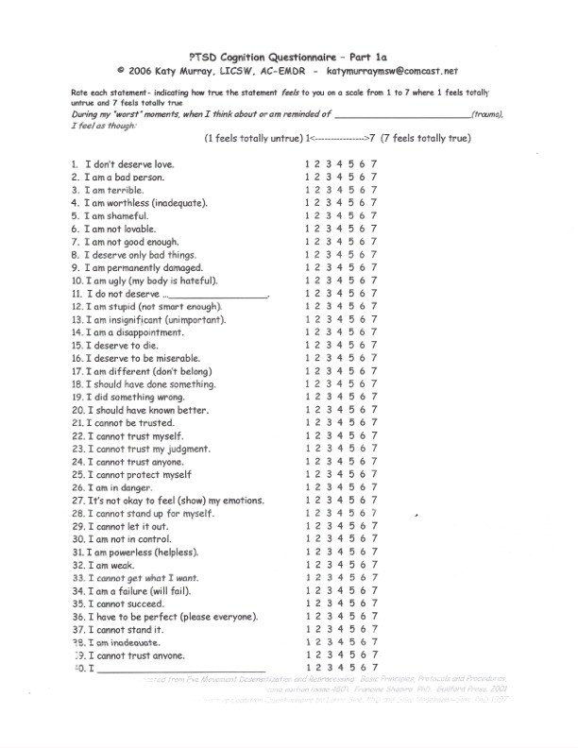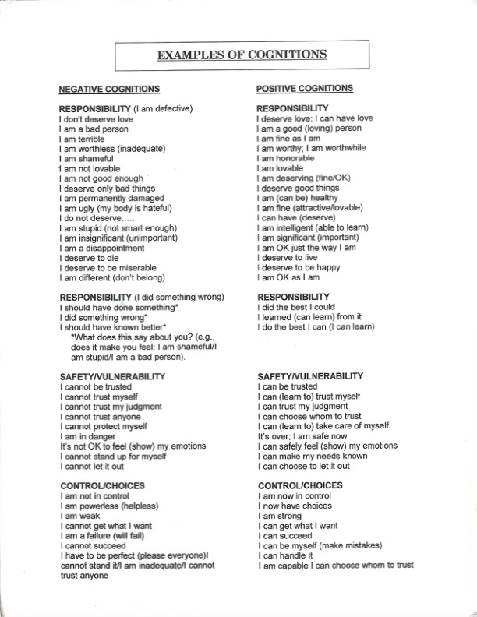

Common Signs of Secondary Trauma
Experiencing lingering feelings of anger, rage, and sadness about a client’s victimization.

Becoming overly involved emotionally with client.

Experiencing bystander guilt, shame, or feeling of self-doubt.

Being preoccupied with thoughts of clients outside of the work situation.

Over identification with the patient (having horror or rescue fantasies.

Loss of hope, pessimism, cynicism

Distancing, numbing, detachment, cutting clients off, staying busy to avoid your own feelings. Avoiding listening to a client’s story of their traumatic experiences.

Difficulty in maintaining professional boundaries with the client, such a as overextending self (trying to do more than is your role to help the individual.

Feelings of re-experiencing of the event, nightmares, and avoidance.
Brain areas affected by trauma
The midline structure of the brain- right above our eyes and all the way back goes OFFLINE in a trauma
Medial Prefrontal Cortex – if damaged by trauma you can’t get in touch with yourself, making it difficult to talk to yourself about being afraid or being in love
Right Temporal Lobe- no thoughts, pure feeling (oh my god!!!) while in a trauma feel dumb founded, speechless terror, you can scream but not with coherent speech
Thalamus – sensory integration is offline
Posterior Cingulus – which tells you where your body is. In a trauma there is nowhere to go thus you feel lost in the world (not connected)
Amygdala-- Trauma takes away your sense of agency, your body never feels safe (hypervigilance)
Ventral Prefrontal Cortex—this is your Watch Tower, core sense of self awareness. After a trauma you struggle with knowing who you are, and you may conform to others wishes without this core sense of yourself.

Acute Stress Disorder Diagnostic Criteria 308.3 (F43.0)
Exposure to actual or threatened death, serious injury, or sexual violation in one (or more) of the following ways:
1. Directly experiencing the traumatic event(s).
2. Witnessing, in person, the event(s) as it occurred to others.
3. Learning that the event(s) occurred to a close family member or close friend. Note: In cases of actual or threatened death of a family member or friend, the event(s) must have been violent or accidental.
4. Experiencing repeated or extreme exposure to aversive details of the traumatic event(s) (e.g., first responders collecting human remains, police officers repeatedly exposed to details of child abuse).
Duration of the disturbance is 3 days to 1 month after trauma exposure. Note: Symptoms typically begin immediately after the trauma, but persistence for at least 3 days and up to a month is needed to meet disorder criteria.

Posttraumatic Stress Disorder Diagnostic Criteria 309.81 (F43.10)
Posttraumatic Stress Disorder Note: The following criteria apply to adults, adolescents, and children older than 6 years. For children 6 years and younger, see corresponding criteria below.
Exposure to actual or threatened death, serious injury, or sexual violence in one (or more) of the following ways:
1. Directly experiencing the traumatic event(s).
2. Witnessing, in person, the event(s) as it occurred to others.
3. Learning that the traumatic event(s) occurred to a close family member or close friend. In cases of actual or threatened death of a family member or friend, the event(s) must have been violent or accidental.
4. Experiencing repeated or extreme exposure to aversive details of the traumatic event(s) (e.g., first responders collecting human remains: police officers repeatedly exposed to details of child abuse).
The duration of the disturbance is more than 1 month.
Specify if: With delayed expression: If the full diagnostic criteria are not met until at least 6 months after the event (although the onset and expression of some symptoms may be immediate)
Posttraumatic Stress Disorder for Children 6 Years and Younger
A. In children 6 years and younger, exposure to actual or threatened death, serious injury, or sexual violence in one (or more) of the following ways:
1. Directly experiencing the traumatic event(s).
2. Witnessing, in person, the event(s) as it occurred to others, especially primary caregivers.
Note: Witnessing does not include events that are witnessed only in electronic media, television, movies, or pictures.
3. Learning that the traumatic event(s) occurred to a parent or caregiving figure
Note: In children older than 6 years, repetitive play may occur in which themes or aspects of the traumatic event(s) are expressed.
Note: In children, trauma-specific reenactment may occur in play.
Note: In children, there may be frightening dreams without recognizable content.

Trauma – is anything you experience that has a lasting adverse impact on your experience. The memories of which can lead to suffering beyond the event.

Small t trauma is more prevalent in our experiences.
Experiences were we unloved, bullied, ignored, rejected or there are losses, and loss of hope.
Where we might feel unsafe someone getting Angry with us with out any sense of control.
We give meaning to these events (negative Cognitions from which we create Stories or reinforce old stories that are negative about ourselves)

Big T trauma is generally considered a life-threatening experience.
DSM-5 Exposure to actual or threatened death, serious injury, or sexual violation in one (or more) of the following ways:
Direct Experience
Witnessing
Learn about a family member or close friend experiencing violence or accidental death.
Experiencing repeated or extreme exposure to aversive details of the traumatic event(s)

Note: Events unimportant to an adult can be devastating to children and have lasting effects.
(ex. Father shooting a family pet that got injured during a bombing)
Trauma Continuum

Small t traumas Big T Traumas

Resilience

ASD PTSD
_______________________________________

Acute Stress Disorder -Symptom lasting few days to 1 month
Post-Traumatic Stress Disorder – Symptoms lasting longer than 1 month.
Primary Trauma- some event(s) which precipitate such am over-whelming affective state that the individual is not capable of assimilating the entirety of the emotional experience at the time of the event. This may cause a subsequent breakdown the relationship between the survivor and his social environment.

EX. Hypervigilance as a trauma symptom– is a state of being subconsciously always anticipating danger, on guard, exceptionally aware of our environment. This is stressful, anxiety-provoking and exhausting. It can impact your ability to interact with your environment and people in it.

EX. The persistence of shame responses even after years of treatment poses a barrier to final resolution of the trauma. Full participation in life, pleasure and spontaneity, healthy self-esteem is counteracted by recurrent shame states and intrusive thoughts. Shame is an intense overwhelming affect associated with autonomic nervous system activation, inability to think clearly, and desire to hide oneself. Shame is driven by the body and reinforced by meaning making (“You should be ashamed”) that reactivates the body responses and intensify the shame •While fear focuses on the source of threat, shame feels personal: it’s about “me”
Trauma clearly leads to suffering.

Maladaptive vs Adaptive Memory
Maladaptive memories (flashback and trauma nightmares) take you back. When you are in this memory you are back in the Trauma. You remember what you thought, felt like and the body sensations that were present when the trauma occurred.
The change from a Maladaptive Trauma Memory to Adaptive Memory with EMDR allows the memory to be detoxified and use as a resource.

