Yoga & Self-Esteem:
Embodying the Satir Toolkit
of Inner Resources

Another way of using the tools of the Satir Self-Esteem Maintenace Toolkit is to embody them through various yoga postures. It can be very enriching to assume these postures when trying to get back in touch with a particular aspect of one’s self-esteem.

These correspondences are not prescriptions but rather possibilities that may strengthen and deepen your self-esteem and your yoga practice.

~Diana Newton
~~~~~~~~~~~~~~~~~~~~~~~~~~~~~~~~~~~~~~~~~~~~~~~~~~~~~~~~~~~~

Detective Hat
Investigation/Analysis



Mindfulness Meditation
The Observer Self



Golden Key
Curiosity



Wishing Wand
Hopes & Wishes



Spinal Twist
Seeing things in a different way
Considering new possibilities

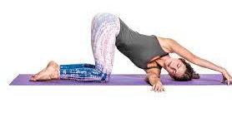

Low Crescent Lunge
Grounded & releasing your hopes to the univer

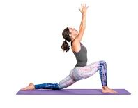

Yes-No Medallion
Congruent choice in decisions



Courage Stick
Courage to be authentic
and take action on our behalf

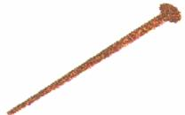

Tree Pose
Balancing the options



Warrior 2 Pose
Focused and energized

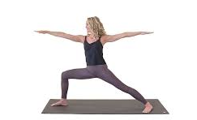

Heart
Aware and accepting
of our feelings



Wisdom Box
Intuition & experience,
Holistic “knowing”

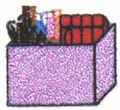

Sphinx Pose
Heart opening

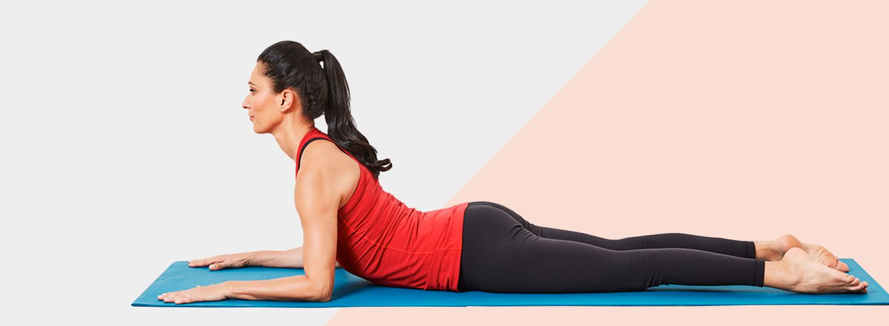

Wisdom/Child’s Pose
Integration, acceptance & rest

